BULLETIN MUNICIPAL
1er Semestre 2024 Numéro 11



Contents
- LA MAIRIE
- IMPORTANT POINTS OF MUNICIPAL COUNCIL MEETINGS
- THE BUDGET FOR THE YEAR 2024
- LIFE IN THE COMMUNE – 1ER SEMESTRE 2024
- MESSAGE FOR ALL CITIZENS
- STILL TO HAPPEN
- FOR YOUR DIARIES : DATESTO REMEMBER FOR THE 2ND SEMESTRE 2024
- PRACTICAL INFORMATION
Legal notices
- Publication director :
Bernard BORNE
- Printing : Mairie de Charmé
- Infographis and paging : Marilyne MELON et William VENUTI
- Communication Commission :
Agnès BAUDRILLART, Sabrina BECHIEAU, Chantal MACHET, Marilyne MELON, William VENUTI (Vice-président)

LA MAIRIE
Secrétariat de Mairie : 5 route de RUFFEC 16140 CHARME
Madame Maryse BRECHET is availableon :
- Lundi de 9h à 12h
- Mercredi de 9h à 12h et de 14h à 17h
- Vendredi de 9h à 12h

 05.45.31.41.61 mairie@charme16083.fr

Site internet : https://www.mairie-charme.fr/
Page facebook : Commune de Charmé

THE ELECTED
Le Mayorand/orthe deputies are availableevery Wednesdayfrom 10h to 12h ou vy appointment.
Appointments can be made at the Secretary’s office at the Town Hall.

THE MAYOR
Bernard BORNE

THE DEPUTIES
Jean Michel RABIOUX
Mickael AUDOUIN

MEMBERS OF THE MUNICIPAL COUNCIL
Agnès BAUDRILLART, Sabrina BECHIEAU, Benoît FRADIN, Chantal MACHET, Marilyne MELON, Louis MOREAU et William VENUTI.

DEPARTMENTAL COUNCILLORS SURGERIES– CANTON DE CHARENTE NORD
Brigitte FOURÉ et Fabrice GEOFFROY
The Town Hall in AIGRE de 11h à 12h every Thursday
The Town Hall in RUFFEC de 11h à 12h every Wednesday
The Town Hall in VILLEFAGNAN de 11h à 12h every Tuesday

THE CHARENTE SENATORS FOR THE CHARENTE
Nicole BONNEFOY
22 G, rue grange du Chapitre 16230MANSLE 05.45.90.15.95 n.bonnefoy@senat.fr

François BONNEAU
314, avenue Jean MONNET 16170 ROUILLAC 06.71.42.56.06 f.bonneau.senat@gmail.com

THE DFEPUTY SURGERIES
Caroline COLOMBIER
2, rue de l’Hôpital 16700 RUFFEC 06.62.78.24.32 caroline.colombier@assemblee-nationale.fr
Les lundis et mercredis de 9h à 13h - 14h à 18h. Les autres jours sur rdv.

THE IMPORTANT POINTS OF MUNICIPAL COUNCIL MEETINGS

- Exceptional purchasing power (PPA) granted to municpal agents.
- Subsisides given to RPI schools and colleges educational outings.
- Internal regulations for the provision of community rooms and the equipment installed.
- Reduction in property taxes rate
- Assignment of a name to the primary school Les Hirondelles, which was chosen by the pupils.
- Creation of a fixed-term contract « temporary increase in activity »,
- Sale of vehicle C15.

THE COMMUNAL BUDGET FOR THE YEAR 2024

The Municpal Council voted the commune budget on 28 March 2024.

Budget for the school funding :
Income | Expenditure | Surplus
55 001,79€ | 43 263,58€ | 11 738,21€

Cumulative surplus : 21 095,38 € +11 738,21€ = 32833,59€

The administrative account is consistent with the management account.
The overall budget forecast for 2024 is81 balanced at 265,59€ with a municpal subsidy of
40 000 €.

Budget for the Commune :
- Investment Section :
Income | Expenditure | Deficit
18 191,35€ | 25 849,62€ | -7 658,27€
- Operating Section :
Income | Expenditure | Surplus
342 894,20€ | 281 970,26€ | 60 923,94€

Budget Estimates for 2024 :Lines are oversized to absorb surplus.
Just a reminder, all the minutes for the Municipal Council meetings are available on the commune’s website.

Investment budget balanced at 166 771,67 €
Operating budgetbalanced at777 408,01 €

WORK CARRIED OUT CURRENTLY DURING THE 1st SEMESTRE 2024

Recently we took advantage of the good weather to partially repair the north roof of the Church with the installation of a protective roof screen and the renewal of the headstock of one of the church bells which was showing signs of weakness.
The work was carried out by Monsieur THERAUD Damien, a roofer, in collaboration with Mickael, our second Deputy, for the repair of the wood for the small bell.

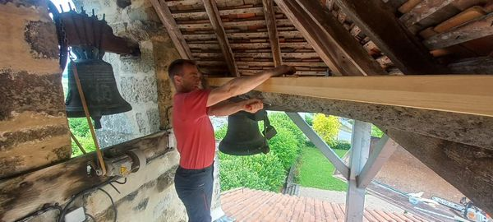

LIFE IN THE COMMUNE– 1ER SEMESTRE 2024

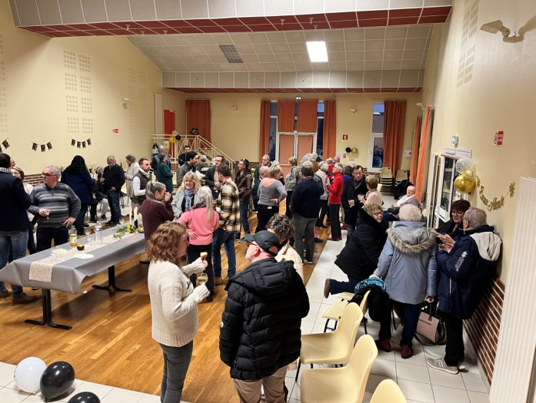
The Mayor’s address on 13/01/2024
This Assemby was aa réuni attended by a large number of Charmésiens.A convivial and warm get together for the beginning of this year.

The Tree of Peace on 20/01/2024
The planting of the Tree of Peace was organised jointly by the commune and the FNACS to commemorate the ceasefire in Algeria. A green oak tree was planted for the occasion in the garden beside the Church.

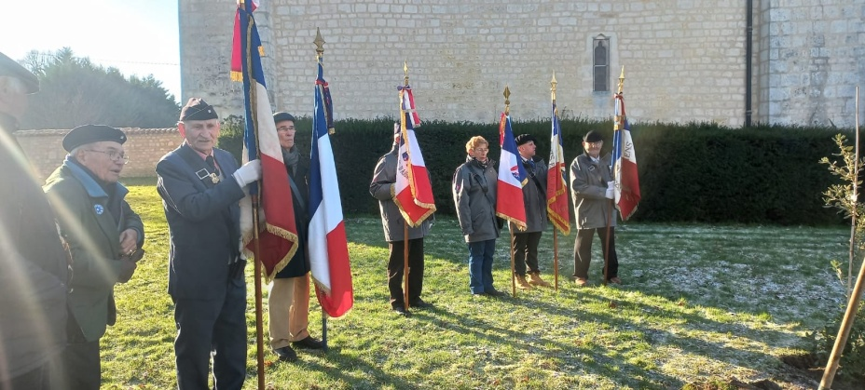

The Show« Le Berger des sons »on 11/02/2024
« Le Berger des sons » est venu dans la salle des fêtes de Charmé le 11 février 2024. We did him honour by having a full house for this evening, and he repaid us with an excellent autobiographical story accompanied by music from around the world, which delighted the many spectators who attended.

The Pensioners’ meal on 17/03/2024 was a great success. All those who came were delighted with the meal prepared by the caterer Stéphane DUMONT et was accompanied by Daniel MUSSET et ses « Mussettes », along withIrish music from Loïs et John.

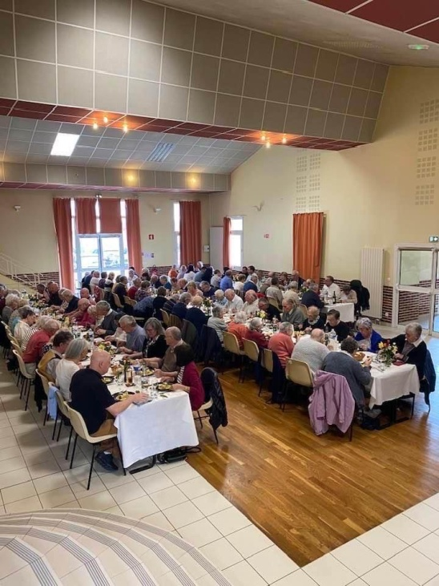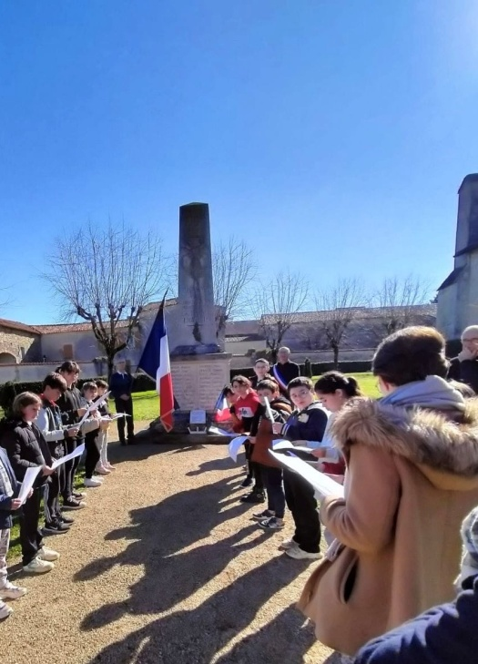

Commemoration of the 19 mars 1962 with the pupils from Charmé’s school

On the occastion of this national day of remembrance and contemplation in memory of the victims, civil and military, of the Algerian war, an official ceremony took place at the War Memorial, in the present of the pupils of Charmé school and their teacher, in order to perpetuate the memory of the historic memory. The pupils read the poem « Liberté » by Paul ELUARD.

The decoration workshop on 23/03/2024 brought together 25 Charmésienswho exhibited a lot of creativity..
Le citizens’ Cafe 2nd édition allowed on the 30/03/2024a number of people to discover the site of thefountainof Roussillon, in beautiful sunshine.

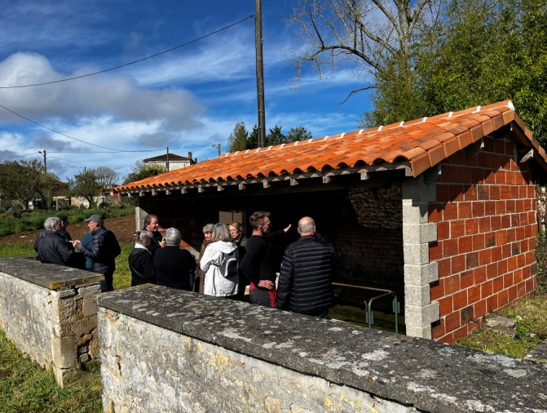

La race« Paul POUX » passed through Charmé on le27/04/2024 heading towards Tusson.

The commemoration ceremony on 08/05/2024, an historic date marking the end of the Second World War, 79 years ago, took place at the War Memoral, followed by a convivial apéritif.
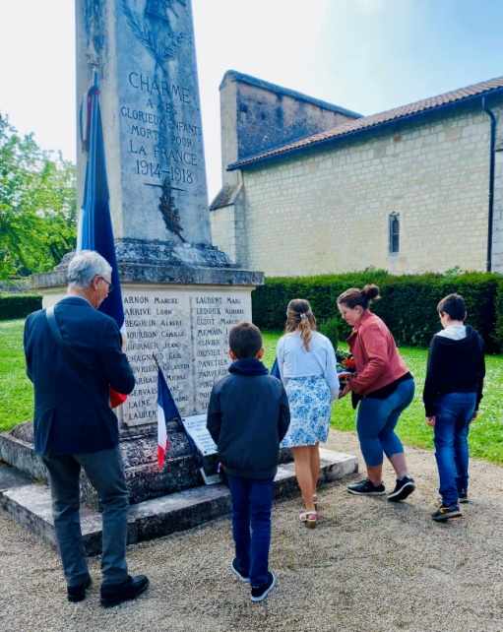

The nature festival on21/05/2024, with a night walk at theplace de l’égliseoraganised by the deparment and the PETR Pays Ruffécois, with the collaboration ofKatia JACQUEL from the gardens of Isis.With the help of white sheets and home made Japanese umbrellas, the participants were able to discover the biodiversity of night time ; night insects living in the hedges, playing an indispensable role in polinisation.
A magnificent natural spectacle. !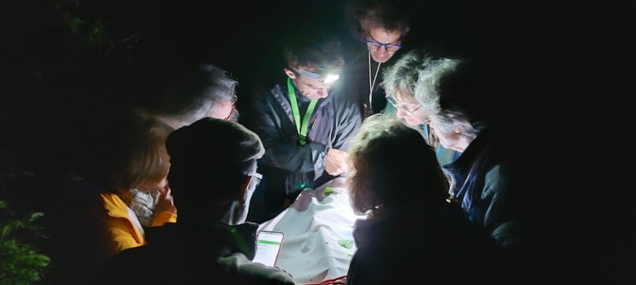

The European elections on 09/06/2024 : 143 peoples voted from 250 registrations.

Le citizen cafe 3ème édition, planned for 29 June 2024 at Le Pontil,didn’t take place because of weather conditions and was put back until06/07/2024.It was a great success in a magnificent setting.
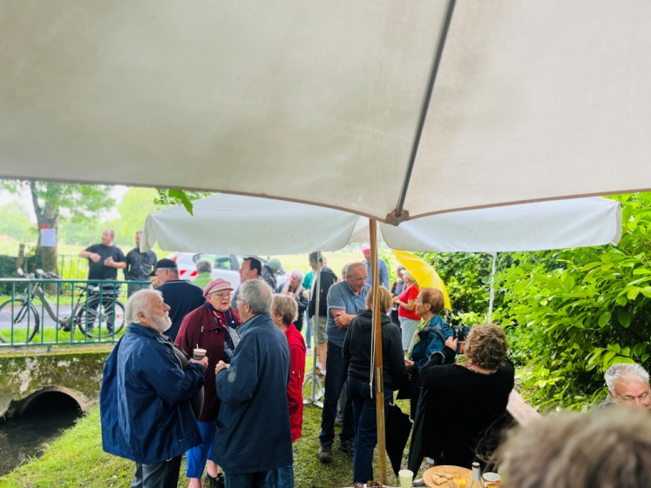
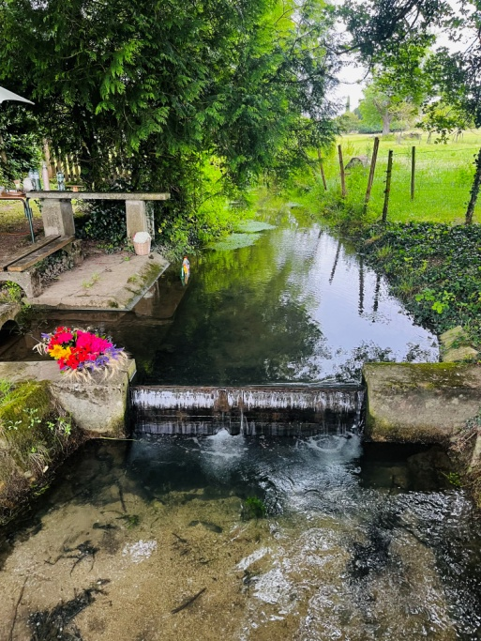

The Suggestions Box illustrated by Pascal ROUX has been fixed to the Town Hall facade, beside the notice board. A big thank you to our favourite painter !

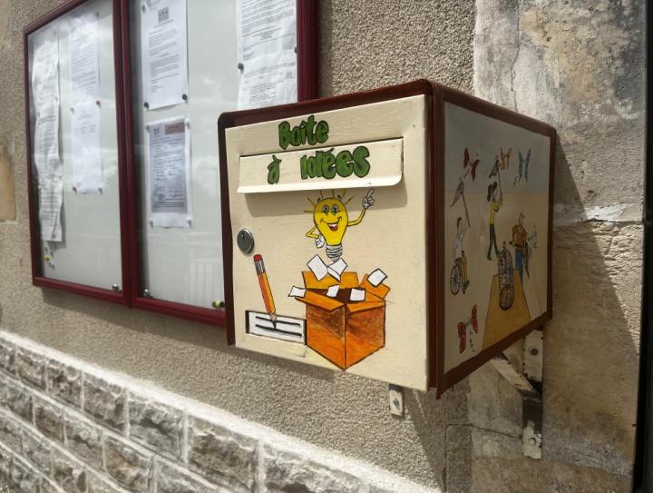

ATTENTION ALL CITIZENS !

BLOOD DONATIONS

Before or during the summer holidays, the collection of blood service needs you to increase the stock of blood. Here are the next dates in the North Charente :
- 16 July : Ruffec, place du jumelage.
- 24 July : Aigre.
- 25 July : Villefagnan 18 rue du champ de foire.
- 29 July : Aunac, place de la mairie.
FUTURE EVENTS

POPULATION CENSUSfrom 16/01/2025 to 15/02/2025

Please greet the census agent with a warm welcome,

NEW WASTE MANAGEMENT 

By the end of 2024, CALITOM will be changing how they operate the collection of household waste, you will be kept informed.
The bin bagswill be transparent, to allow them to be inspected by the waste collectors, and at first the bags will be distributed byCALITOM, until they are marketed in the supermarkets. New waste bins will be supplied free of charge by CALITOM.
The collection timetable will not change for the black waste bins. On the other hand,the yellow waste bins wil be emptied every week..
The black bins will be used for household wasteusing the transparent bags et the yellow bins will be forrecycle waste in bulk.The supply of the yellow bags will be stopped from September by CALITOM.
ANY BAG LEFT OUTSIDE THE WASTE BINS OR ON THE PAVEMENTS WILL NOT BE COLLECTED.
The bins must be put out the day before the collection day and returned to your property on the collection day..
For the sake of hygiene, NON-COMPLIANCE WITH THIS INSTRUCTIONS WILL INCUR A FINE !
A little reminder, what to put in the different waste bins ?
- YELLOW BIN :
All food plastics, (trays, pots, boxes, bags, plastic bags, plastic film, water bottles, fruit juice and soda bottles), all cartons, papers (catalogues, notebooks, books, newspaper, magazines, envelops, empty bottles of household products and toiletries.
Certain metal containers (boxes, cans, trays, aerosols, small steel and aluminium containers.
- BLACK BIN (transparent bag) :
All non-recyclable waste, (nappies, soiled paper and paper towels, broken dishes and small objects, soiled cardboard), single use products (wipes, disposable razors, toothbrushes, sponges, cotton buds,sanitary towels)
- COMPOSTER (1st composter free !) :
Crushed egg shells, crushed walnut and hazelnut shells, dead leaves, coffee grinds, spoiled fruit, fruit skin in pieces, unprinted cartons(egg boxes) unprinted paper napkins, fruit and vegetable peelings, grass clipplings, small leftovers from meals (pasta, rice, cheese crusts…) wilted flowers
You can find other suggestions on the CALITOM website as well as Charmé’s website to help you recycle your waste !

CLOSURE OF THE COPPER TELECOMMUNICATION NETWORK

A large page in the history of telecommunications is about to be turned !

For more than fifty year, the copper network has accompanied people in France in their communications.At first reserved for the telephone, it finally allowed the general use of high speed internet, thanks to ADSL. Having come to the end of its life, the copper networkis being closedand being replace by fibre optic (or other pertinent technologies).


Charmé is one of the 162 communes which is taking part in the first steps to close the copper network of our classic telephone line.

This will lead to two scenarios :
- You have already subscribed to a « fibre optic » contract with a supplier et in that case,you have nothing to do,the closure of the network will not affect you.
- You have a contract on the copper network,in this case, you have until 31 January 2025 to change to the new technologies (fibre optice subscription, mobile telephone subscription, …)

What are the advantages of fibre optic ?
It offers higher speeds than those available on the copper network.
The signal is a better quality for an optimal internet connection.
Fibre optic also allows you to connect several devices simultaneously with a smoothless seamless connection for each.
The recent construction of the fibre optic network guarantees a greater scalability in the face of increased flow rates and thereforegreater sustainability.
And finally, fibre optic offers a better energy performance : a switch to fibre divides by 4 the energy consumption of the fixed line.

This affects both individuals as well as professionals !

FOR YOUR DIARIES : DATES TO REMEMBER FOR THE 2nd SEMESTRE 2024
- 14 July :walk-running et brunch organisedbythe association « Charmé-Baustert »,
- 10 August :meal« HANGI »organisedby the comité des fêtes,
- 24 August :Village picnic organised by the comité des fêtes,
- During September :Citizen Cafeat the lavoir in the village of « Les Inchauds »,
- 14 September :Decoration workshop organsied by theassociation BVAC (Bien Vivre A Charmé),
- 5 October :« Octobre ROSE »,various get togethers organised bythe participating associations ,
- 20 October :repas tartiflette organised by the association « Charmé-Baustert »,
- 24 October : My Future House organised by the département,
- 24 November : Xmas Marketorganised by the association « Charmé-Baustert »,
- 7 Décember : Decoration Workshoporganised by the association BVAC (Bien Vivre A Charmé),
- During Décember : Citizen Cafe« in the garden de BOULITE »at Quincornet.

Possibilité d’autres évènements à venir !

PRACTICAL INFORMATION

Emergency Numbers
SAMU : 15
Fire Brigade : 18
Police : 17 ou 05.45.31.60.11
Appels d’urgence : 112
Emergency no for people who are deaf or hard of hearing : 114
Domestic Violence : 3919
Child in danger (disappearance ou violence) : 119
EDF – ELECTRICITY : 09.72.67.50.16
SAUR – WATER : 05.87.23.10.00

LES SERVICES
POST OFFICE : Tatiana will welcome you Monday to Friday from 9h à 12h.

BREAD AND CHARENTE LIBRE DEPOT : From Monday to Friday from 9h à 12h. And Saturday from 9h à 11h.
RECYCLING CENTRE AT VILLEJESUS : 05.45.21.32.50
Monday, Wednesday, Thursday, Saturday from 9h/12h - 14h/18h. And Tuesday from 14h/18h.
JUSTICE CONCILIATOR :
M. Christian SANDOVAL, contact by email christian.sandoval@conciliateurdejustice.frto arrange an appointment at Aigre or Ruffec or Villefagnan.
TAX CENTRE RUFFEC : 05.45.30.77.80
SANITATION : Communauté de communes de Cœur de Charente 05.45.20.71.33

JOBCENTRE FRANCE RUFFEC : 3995

MAISON DEPARTEMENTALE DE LA SOLIDARITE : 05.16.09.51.01

ADMR (Help at home in the country) : Secteur d’Aigre : 05.45.21.21.31

EMMABÜS (Espace France Services) on holiday from 05 to the 25 août
Mobile and free office–SALLE DES FÊTES–Every second Tuesday from 13h30 - 16h30

LOCATION DE LA SALLE DES FETES ET DU STADE
To book the salle des fetes or the sports stadium, please contact the secretary’s office in the Town Hall.
You can find the charges for 2024 on the commune website.

